OLATUNJI DAVID OLUSOLA
Contact Address: Anifowose, Ikeja, Lagos Tel: (+234) 8025367919, 08055572500
Email: dolatunji72@yahoo.com; dolatunji72@gmail.com
～SALES OPERATIONS MANAGER | BUSINESS DEVELOPMENT MANAGER～
MORE THAN 17 YEARS OF EXPERIENCE IN THE NIGERIAN TELECOMS/FMCG SECTOR
OVER 15+ YEARS’ EXPERIENCE spanning through relationship management, business development, sales & marketing, customer acquisition, and strategic planning within the Nigerian telecoms/FMCG sectors.  Sound knowledge product management and customer segmentation, strategy and implementation and marketing strategy formulation, product distribution, and most recently, and sales consulting and advisory services.  Proficient in helping both small and, mid-size, and large corporations double and grow revenues and EBITDA performance. | 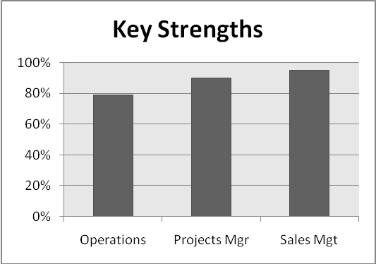
CORE AREAS OF EXPERTISE
- Strategic Prospecting Skills  - Account Management  - Cross-Cultural Talent Training and Development  - Productive/Effective Communication  - Win-Win Negotiation  - Analytical Assessment  - Internal Project Documentation | - Multimillion Naira Revenue Maximization  - Business Strategic Planning  - Pre/Post Sales Relationship Management  - Discrepancy Remediation  - Territory Management  - New product/ Market Management | - Complex Change Management  - Performance Management  - Product Knowledge  - Objection Handling  - Client Service Lead  - Effective Communication  - Portfolio Management  - Problem Solving/Solution provider  - EBIT Improvement

PROFESSIONAL EXPERIENCE
GLOBACOM LIMITED
Activation Manager (Sales Backend) July 2018 - Date
- Sales Growth - Partnered the service and professional sales team efforts to win and keep winning market share
- Leadership - Fostered a robust environment, which promoted collaboration across teams, accountability, and overall business success.
- Developed and maintained a professional network with customers, key stakeholders, and industry experts including regulatory and other bodies in the industry
- Boosted net profitability by additional 4% in the business development group
- Strategically organized and coordinated with senior executives new business trends to develop new services, products, and distribution of channels.
- Targeted and developed "new customers" by identifying key decision makers, demonstrating a strategic selling approach, and successfully positioning the company's value proposition

Divisional Manager-E Business (WEST-Oyo 1,2,3 & Osun) June 2017-June 2018
- Directed and transformed overall strategy, market intelligence, and research as well as customer-centric activities that contributed to growth
- Carefully designed a marketing strategy which improved the meeting of B2B sales targets
- Succeeded in bringing customer satisfactions scores to 95% and higher by creating a team focus and using customer centric processes
- Built customer acquisition strategy that generated consistent monthly growth of at least 10%

State Manager-Retail (LAGOS 3) January-June 2017
- Streamlined Client Services: Developed client relationships, restructured client delivery processes and improved shared service operational controls, increasing profit margins.
- Client Satisfaction - Responsible for relationships with the territory's top revenue generating clients
- Developed and maintained a professional network with customers, key stakeholders, and industry experts including regulatory and other bodies in the industry
- Delivered 3-8% above target consistently through efficient collaboration with other teams and excellent reviews with stakeholders and great relationship management
- Overhauled customer satisfactions scores to 95% and higher by creating a team focus and using customer centric processes

Career achievements highlights with Globacom:
- Managed over 27 direct reports in Enugu Cluster
- Created, developed new business strategy, platform and opportunities for Data Dealers, Phone and allied outlets
- Grew successfully the Data business in Enugu cluster by 32% in 8 months
- Inducted a total of 27 Dealer sales outlets within 3 months

Previous work experiences highlights:
- Cluster Head-Data & Non-Voice (South East-Enugu, Abia, Ebonyi, Imo, Anambra/ Benue and Lagos) July 2013 –January 2017
- Area Head (Ibadan), Visafone Communications Limited (Acquired by MTN) 2012 - 2013
- Sales Manager (Lagos 2), Globacom Limited, 2011 - 2012
- Territory Manager - Just Dial (Lagos Region), Globalcom Limited, 2010 - 2011
- Manager (Petroleum Focus, HQ), Globalcom Limited, 2008 - 2010
- Trade Marketing & Distribution (Badagry, Surulere & Yaba, Lagos) ==> Trade Marketing & Distribution Wholesale Executive (Oke Arin, Lagos), British American Tobacco Nigeria, 2003 - 2006
EDUCATIONAL QUALIFICATIONS, TRAINING & OTHER CERTIFICATIONS
M.Sc Industrial & Organizational Psychology, University of Ibadan, Ibadan, Nigeria
B. Sc (HONS) General & Applied Psychology, (Second Class Upper), University of Jos, Nigeria
Diploma in Law, Kwara State Polytechnic, Ilorin, Nigeria
Career Development Training Programs:
Lagos Business School - Interpersonal Skills Seminar, Negotiation Skills and Tools; Phillips Consulting - Marketing and Selling Essentials; British American Tobacco (B & H Soul and Substance Academy), Environment, Health and Safety Training, Marketing Excellence Series (MXS); Pro Sellers - Sales Masters (FMCG); KPMG - Tax Education Workshop; Change Management Associate - Leadership Experience Programme; FRSC/ BAT - Practical Defensive Driving Course; Institute of Direct Marketing of Nigeria (IDMN) - Graduate Membership Fast Track programme (2003); Vic Lawrence - Personal Development Programme
In-house training:
Siebel Navigation for TME & FOM - (Trade marketing execution & Field order managers); BAT Nigeria - Product Appreciation, Presentation Skills, Distribution Edge Series, CES Intro

